Collier Rhodes
EN-381-001
11/04/25
Dr. Veronie
Fluoride vs Nano-Hap: Comparing Ingredients That Rebuild Enamel
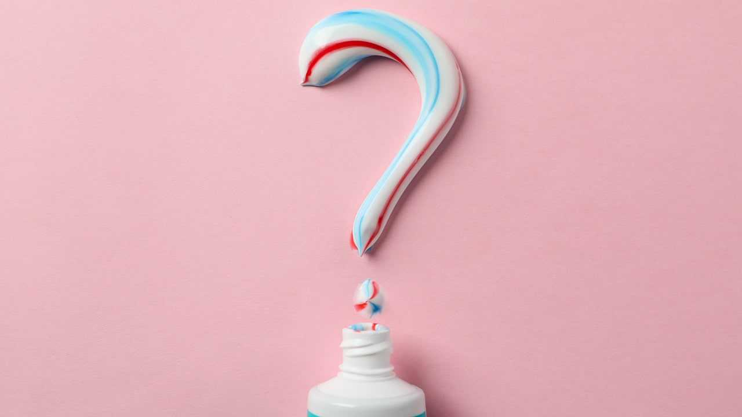
Oral care has always been an important part of everyone’s life. Through brushing, flossing, and the works we take care of our oral hygiene for both ourselves and others (let’s not have foul-smelling breath, people) so that we can stay healthy, happy, and smiling. The way we modern folk keep our pearly whites is through specific chemicals; substances that clean and re-mineralize our enamel. For over 70 years the preferred ingredient (of the CDC, ADA, etc.) for toothpaste has been fluoride, but in recent years a new ingredient, nano-hydroxyapatite (HA), has been gaining popularity. The choice between fluoride and HA has been a hot topic, and it is important that you stay informed about the important differences of the two.
Fluoride and nano-hydroxyapatite accomplish similar things, so the main debate surrounding the two are how both compounds differ, and which of the two have more upsides and less downsides. Of the two, both fluoride and hydroxyapatite have the capabilities of reducing tooth sensitivity and whitening through remineralization.
- https://www.goodrx.com/conditions/dental-care/hydroxyapatite-toothpaste-vs-fluoride?srsltid=AfmBOooJcOOLj_1ENzzSXy7wnMkeE8dlYMl93pFavThLxNs7hUVoVflU
Fluoride and YOU
Enamel, the outer layer of our teeth, faces repeated mineral loss and gain over time. The loss of minerals due to plaque and sugars in our enamel can be counteracted by remineralization by consuming food and water that contain the same minerals in our teeth (fluoride, calcium, and phosphate). Dental use of fluoride can assist in enamel repair through remineralization, defending your teeth from acids. This remineralization is done through fluoride bonding to the calcium and phosphate in enamel to form a stronger surface material called fluorapatite. Compared to other oral hygiene solutions, fluoride’s properties have been heavily researched and proven through extensive investigation and practical use on real teeth. Fluoride applied properly can strengthen teeth and reduce the risk of cavities by approximately 25% (see the article provided below).
- https://my.clevelandclinic.org/health/treatments/11195-fluoride
The Alternative: Nano-Hydroxyapatite
Nano-Hydroxyapatite (Nano-HAp) shares many of fluoride’s benefits: remineralization, effective reduction of tooth sensitivity, and HA has some clinical evidence of strengthening enamel to prevent cavities. While not used in the same way fluoride is used in fluoridation, hydroxyapatite is used within toothpaste as an alternative to fluoride. Hydroxyapatite is advertised as an “all natural” alternative because of the nature of the compound itself; HA is composed of manufactured calcium phosphate, the same minerals that form tooth enamel. Because of how new the use HA in clinical studies is, there are fewer studies that observe the chemical, but some studies show that hydroxyapatite is equally effective as fluoride in preventing cavities. For mor information regarding hydroxyapatite toothpaste and fluoride, visit the article below.
- https://www.webmd.com/oral-health/hydroxyapatite-toothpaste
Staying Informed
Since the fluoride debate has begun, shocking research and scientific developments have warned of problematic side effects of water fluoridation, the practice of adding trace amounts of fluoride to residential water sources to generally improve dental health. Because of this, sensationalized articles and social media posts have been created to provide dental advice to those interested, regarding topics such as fluoride’s dangers or fluoride alternatives. It is important to understand that with unsolicited dental advice from uncertified sources like the Tik-Tok “for-you page” may bring dental misinformation. A misinformed customer may take improper actions regarding their oral healthcare, a problem that detracts from actual scientific progress in the dental field.
- https://pmc.ncbi.nlm.nih.gov/articles/PMC10956376/
Fluoride: The Cons
Fluoride has its downsides: fluorosis in teeth is one such example. Fluorosis only occurs
when fluoride is consumed in excessive amounts during tooth enamel’s developmental stages. Fluorosis symptoms are discoloration, rough or uneven tooth surfaces, or enamel defects like pitting or grooves. Other side effects associated with overexposure to fluoride are neurodevelopmental disorders in children, cancer, and thyroid disease, but these conditions are only observed in fluoridated water sources. However, water fluoridation can be safe when added in proper amounts to a source, and these negative conditions are seen more in improperly fluoridated water sources such as natural water pools heavily containing fluoride. According to the CDC, ADA, and the U.S. Public Health Service, the proper fluoridation level of water is 0.7 milligrams per liter.
- https://pmc.ncbi.nlm.nih.gov/articles/PMC6195894/
Hydroxyapa-who?
Nano-HAp has its own set of issues: not dangers that hydroxyapatite poses for the subject, but instead the lack of researched and backed information that vouches for the chemical’s alleged benefits. Because of fluoride’s decades of clinical trials and trustworthy research proving its effectiveness, movements pushing hydroxyapatite as a fluoride alternative are not enthusiastically supported by the dental community. The simplicity of keeping fluoride -a proven oral care solution- over hydroxyapatite holds the rising chemical back from more clinical research. Other known shortcomings HA may have include unfamiliar texture, less effective for severe tooth damage, and less availability. Because of hydroxyapatite’s uncertainty, companies that claim to use HA in their products tend to either use the incorrect form of hydroxyapatite or lack the chemical entirely. One significant factor that influences the lack of trusted hydroxyapatite toothpastes is that HA has not seen approval by the ADA to be included in toothpaste. Linked below is an article that digs deeper into the reported downsides of hydroxyapatite.
- https://metropolitandentalarts.com/unpacking-the-potential-negatives-of-hydroxyapatite-toothpaste/
The difference between hydroxyapatite (in its many forms) and fluoride may very well continue to put the two chemicals at odds. If you can stay properly educated on each chemical and its emerging forms, preferably a trusted HA toothpaste, I have hopes that one day both of these chemicals may be used in tandem to further improve the oral health of people all around the world.

